Ideation Phase Empathize & Discover

|  |  |
| --- | --- |
| Date | 15 October 2022 |
| Team ID | PNT2022TMID39135 |
| Project Name | Natural Disasters Intensity Analysis And  Classification Using Artificial Intelligence |
| Maximum Marks | 4 Marks |

**Empathy Map Canvas:**

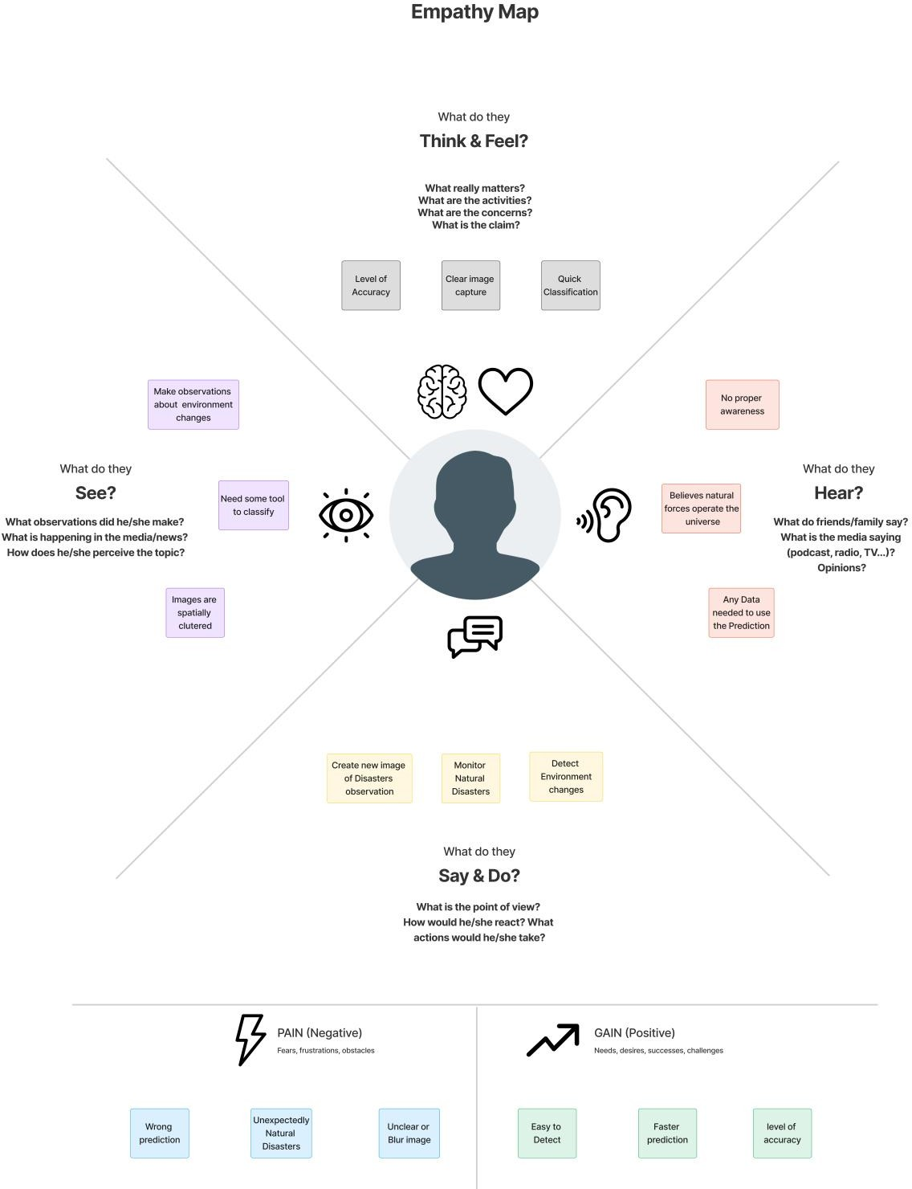**s**